**TECH SAKSHAM**

Capstone Project Report

ARTIFICIAL INTELLIGENCE AND MACHINE LEARNING FUNDAMENTALS

“Government College Of Engineering, Dharmapuri”

|  |  |
| --- | --- |
| NM ID | NAME |
| au613521105031 | T.Poonkuzhali |

Trainer name,

Ramar

**ABSTRACT**

Spam email detection is a critical task in modern communication systems to ensure the security and integrity of electronic communication. This abstract outlines the key approaches and techniques used in detecting spam emails, including machine learning algorithms, natural language processing techniques, and heuristic filtering methods. The effectiveness of these methods is evaluated through metrics such as accuracy, precision, recall, and F1 score. Additionally, the challenges and future directions in spam email detection are discussed, highlighting the need for continuous innovation and adaptation to counter evolving spamming techniques.

**INDEX**

|  |  |  |
| --- | --- | --- |
| **Sr.no** | **Table of contents** | **Page NO** |
| **1.** | Chapter 1:Introduction |  |
| **2.** | Chapter 2:Service and Tools required |  |
| **3.** | Chapter 3:Project architecture |  |
| **4.** | Chapter 4:Project Outcome |  |
| **5.** | Conclusion |  |
| **6.** | Future Scope |  |
| **7.** | References |  |
| **8.** | Code |  |

**CHAPTER 1**

**INTRODUCTION**

* 1. **Problem statement:**
  2. **Proposed Solutions**
  3. **Features**
  4. **Advantages**
  5. **Scope**
  6. **Future work**
  7. **Problem statement:**

The problem statement in spam email detection typically involves addressing the challenge of accurately identifying and filtering out unwanted or potentially harmful emails while ensuring that legitimate emails are not incorrectly classified as spam. This encompasses several key aspects:

Detection Accuracy: Developing algorithms and techniques to effectively distinguish between spam and legitimate emails, considering factors such as content analysis, sender reputation, and email metadata.

Adaptability: Creating a system that can continuously evolve and adapt to new spamming techniques and patterns, ensuring that it remains effective against emerging threats.

Scalability: Designing a solution that can handle large volumes of email traffic efficiently without sacrificing detection accuracy or performance.

Minimization of False Positives: Minimizing the occurrence of false positives, where legitimate emails are mistakenly classified as spam, to avoid disrupting communication between users and causing inconvenience.

User Experience: Ensuring that the spam detection system integrates seamlessly into users' email workflows and does not impose unnecessary restrictions or inconvenience on legitimate email communication.

Overall, the problem statement in spam email detection revolves around creating a robust and reliable system that effectively protects users from spam while maintaining the usability and efficiency of their email communication.

**1.2Proposed Solutions:**

A proposed solution in spam email detection involves implementing a comprehensive approach that combines multiple techniques and technologies to accurately identify and filter out spam emails. Here's an outline of the proposed solution:

Content Analysis: Utilize natural language processing (NLP) techniques to analyze the content of incoming emails, looking for common spam characteristics such as deceptive language, phishing attempts, or promotional content.

Sender Reputation Analysis: Implement mechanisms to assess the reputation of email senders based on factors such as IP reputation, domain reputation, and past email behavior. This helps identify known spammers and suspicious sources.

Machine Learning Models: Develop and train machine learning models using labeled datasets to automatically classify emails as spam or legitimate. These models can continuously learn and adapt to new spamming techniques and patterns.

Behavioral Analysis: Monitor user behavior and interaction with emails to identify anomalies or suspicious activities that may indicate spam or phishing attempts. This could include analyzing click-through rates, response patterns, and email engagement metrics.

Blacklists and Whitelists: Maintain updated blacklists of known spam sources and whitelists of trusted senders to supplement automated detection methods and improve accuracy.

* 1. **Features:**

Spam email detection systems typically incorporate various features to effectively identify and filter out unwanted emails. Here are some common features found in such systems:

Content Filtering: Analyzing the content of emails for typical spam indicators such as keywords, suspicious URLs, and phishing attempts.

Sender Reputation Analysis: Assessing the reputation of the sender's domain and IP address to identify known spammers or suspicious sources.

Machine Learning Algorithms: Using machine learning models trained on labeled datasets to automatically classify emails as spam or legitimate based on various features and patterns.

Blacklists and Whitelists: Maintaining lists of known spam sources (blacklists) and trusted senders (whitelists) to aid in classification.

Header Analysis: Examining email headers for anomalies or inconsistencies that may indicate spam or spoofing.

Behavioral Analysis: Monitoring user behavior and interaction with emails to detect anomalies or suspicious activities.

Real-time Monitoring: Constantly monitoring incoming email traffic for new spam outbreaks or patterns.

Heuristics and Rules-based Filtering: Applying predefined rules and heuristics to classify emails based on characteristics such as sender address, subject line, and content.

Phishing Detection: Identifying and flagging emails that attempt to trick recipients into divulging sensitive information or visiting malicious websites.

Automatic Updates: Regularly updating spam detection algorithms and databases to adapt to new spamming techniques and patterns.

Feedback Mechanisms: Allowing users to report spam emails and provide feedback to improve the accuracy of the detection system.

Integration with Email Platforms: Seamless integration with email platforms and services to provide users with a smooth experience while effectively filtering out spam.

These features work together to create a robust spam detection system that helps protect users from unwanted and potentially harmful emails while minimizing disruptions to legitimate communication.

* 1. **Advantages:**

Spam email detection offers several advantages for both individuals and organizations:

Protection from Unwanted Emails: Spam email detection systems help users filter out unwanted emails, including unsolicited advertisements, phishing attempts, and malware-laden messages, reducing the clutter and potential risks associated with spam.

Enhanced Security: By identifying and blocking spam emails, these systems help protect users from phishing attacks, malware infections, and other security threats that may be concealed within spam messages.

Improved Productivity: By reducing the time spent sifting through spam emails, users can focus more on important tasks and communications, leading to increased productivity and efficiency.

Cost Savings: Spam email detection can help organizations save money by reducing the bandwidth, storage, and processing resources consumed by spam emails, as well as minimizing the potential costs associated with security breaches and malware infections.

Protection of Reputation: Spam filtering helps organizations maintain a positive reputation by preventing spam emails from being sent to customers, partners, and employees, which can damage trust and credibility.

Regulatory Compliance: For organizations operating in regulated industries, such as healthcare and finance, implementing spam email detection systems can help ensure compliance with data protection and privacy regulations by reducing the risk of unauthorized access or disclosure of sensitive information.

Customization and Control: Many spam detection systems offer customization options and advanced filtering rules, allowing users to tailor the filtering criteria to their specific needs and preferences.

Continuous Improvement: Spam detection technologies are continually evolving to adapt to new spamming techniques and patterns, providing ongoing protection against emerging threats and ensuring the effectiveness of the detection system over time.

Overall, spam email detection provides numerous benefits in terms of security, productivity, cost savings, and regulatory compliance, helping users and organizations mitigate the risks associated with spam emails and maintain a safe and efficient email environment.

* 1. **Scope:**

The scope of spam email detection encompasses various aspects related to identifying and filtering out unwanted or potentially harmful emails. Here are some key components within the scope of spam email detection:

Content Analysis: Examining the content of emails to detect spam characteristics such as deceptive language, suspicious URLs, and phishing attempts.

Sender Reputation Analysis: Assessing the reputation of email senders based on factors such as IP reputation, domain reputation, and past email behavior.

Machine Learning Models: Developing and implementing machine learning algorithms to automatically classify emails as spam or legitimate based on patterns and features extracted from the data.

Behavioral Analysis: Monitoring user behavior and interaction with emails to detect anomalies or suspicious activities that may indicate spam or phishing attempts.

Blacklists and Whitelists: Maintaining lists of known spam sources (blacklists) and trusted senders (whitelists) to aid in classification.

* 1. **Future work:**

Future work in spam email detection may focus on several areas to further enhance the effectiveness and efficiency of spam filtering systems. Some potential avenues for future research and development include:

Advanced Machine Learning Techniques: Exploring and implementing advanced machine learning algorithms, such as deep learning and ensemble methods, to improve the accuracy and adaptability of spam detection models.

Behavioral Analysis and User Profiling: Investigating user behavior and email interaction patterns to develop more sophisticated behavioral analysis techniques for identifying spam and phishing attempts.

Natural Language Processing (NLP): Leveraging NLP techniques to better understand and analyze the content of emails, including semantic analysis, sentiment analysis, and context-aware filtering.

Real-time Threat Intelligence Integration: Integrating real-time threat intelligence feeds and data sources to enhance spam detection capabilities and quickly identify emerging threats and spamming techniques.

Enhanced Sender Reputation Analysis: Developing more robust algorithms for assessing the reputation of email senders, including reputation scoring mechanisms and advanced anomaly detection techniques.

Multi-layered Defense Mechanisms: Implementing multi-layered defense mechanisms that combine various detection techniques, including content analysis, sender reputation analysis, and behavioral analysis, to provide comprehensive protection against spam and phishing attacks.

Privacy-preserving Techniques: Investigating privacy-preserving techniques for spam detection that protect user privacy while still allowing effective spam filtering to take place.

Adversarial Attack Mitigation: Researching methods to defend against adversarial attacks aimed at evading spam detection systems, including adversarial training, robust feature extraction, and adversarial example detection.

User-centric Design and Feedback Mechanisms: Incorporating user feedback mechanisms and user-centric design principles to improve the usability and effectiveness of spam filtering systems and address user-specific preferences and requirements.

Integration with Emerging Technologies: Exploring integration with emerging technologies such as blockchain, decentralized identifiers (DIDs), and decentralized email protocols to enhance email security and privacy.

By focusing on these areas of future work, researchers and practitioners can continue to advance the state-of-the-art in spam email detection and develop more robust, adaptive, and user-friendly solutions to combat the evolving threat landscape posed by spam and phishingz

**CHAPTER 2**

**SERVICES AND TOOLS REQUIRED**

**2.1 Services used:**

Spam email detection services often use a combination of techniques, including content filtering, sender reputation analysis, machine learning algorithms, and pattern recognition to identify and filter out spam messages. Some popular services include SpamAssassin, Barracuda Spam Firewall, and Proofpoint.

**2.2 Tools and Software used:**

Several tools and software are commonly used in spam email detection. Here are some popular ones:

SpamAssassin: An open-source spam filter that uses a variety of spam-detection techniques such as header analysis, Bayesian filtering, and DNS-based blacklists.

Barracuda Spam Firewall: A hardware and software solution that provides inbound and outbound email filtering, including spam and virus detection.

Proofpoint: Offers email security solutions that include spam and phishing detection, email encryption, and data loss prevention.

Symantec Email Security: Provides protection against spam, phishing, malware, and targeted attacks through its email security solutions.

McAfee Email Protection: Offers spam and malware detection, data loss prevention, and email encryption to secure email communication.

MailWasher: A desktop-based spam filter that allows users to preview and delete spam emails before they reach their inbox.

Microsoft Exchange Online Protection (EOP): A cloud-based

**CHAPTER 3**

**PROJECT ARCHITECHTURE**

**3.1 Architechture:**

The architecture used in spam email detection typically involves multiple components working together to analyze incoming emails and determine whether they are spam. Here's a high-level overview of a common architecture:

Ingress Point: Incoming emails are received at the ingress point, which could be an email server or gateway.

Pre-Processing: Emails undergo pre-processing to extract metadata such as sender information, subject line, and email headers.

Content Analysis: The content of the email, including text and attachments, is analyzed using various techniques such as keyword matching, Bayesian filtering, and machine learning algorithms to determine the likelihood of it being spam.

Sender Reputation Analysis: The reputation of the sender's domain and IP address is assessed to identify known spammers or suspicious sources.

Blacklists and Whitelists: Emails are compared against blacklists of known spam sources and whitelists of trusted senders to further classify them.

Machine Learning Models: Advanced spam detection systems may use machine learning models trained on large datasets to continuously improve detection accuracy and adapt to new spamming techniques.

Rules Engine: A rules engine applies predefined rules and policies to classify emails based on various criteria such as content, sender reputation, and email headers.

Decision Engine: Based on the results of content analysis, sender reputation analysis, and rule evaluation, a decision engine determines whether an email should be classified as spam or legitimate.

Action: Depending on the classification, emails are either delivered to the recipient's inbox, placed in a spam folder, or rejected outright.

Feedback Loop: Feedback mechanisms collect data on the effectiveness of spam detection techniques, which is used to improve the system over time.

This architecture is flexible and can be adapted to suit the specific requirements and scale of different email filtering systems**.**

**CHAPTER 4**

**PROJECT OUTCOME**

The outcome of a spam email detection project typically involves achieving high accuracy in identifying and filtering out spam emails while minimizing false positives (legitimate emails mistakenly classified as spam). Key metrics for evaluating the success of the project include:

Detection Accuracy: The percentage of spam emails correctly identified and filtered out by the system.

False Positive Rate: The percentage of legitimate emails incorrectly classified as spam.

Precision: The proportion of emails classified as spam that are actually spam (true positives).

Recall: The proportion of actual spam emails that are correctly identified by the system (true positives).

Overall Efficiency: The system's ability to handle large volumes of email traffic efficiently without significant delays or performance issues.

User Satisfaction: Feedback from end users on the effectiveness and usability of the spam filtering system.

Ultimately, the desired outcome is to create a spam detection system that effectively protects users from unwanted and potentially harmful emails while minimizing disruptions to legitimate communication.

email filtering service that helps protect against spam, malware, and other email threats for Microsoft Exchange Online customers.

These tools and software employ various techniques, including content analysis, sender reputation checks, machine learning, and heuristics, to effectively detect and filter out spam emails.

**CONCLUSION**

In conclusion, implementing effective spam email detection systems is crucial for safeguarding users and maintaining the integrity of communication platforms. By employing advanced machine learning algorithms, robust filtering techniques, and continuous monitoring, we can significantly reduce the prevalence of spam emails, enhancing user experience and security.

**FUTURE SCOPE**

The future scope in spam email detection is promising, with ongoing advancements in machine learning, natural language processing, and cybersecurity. Some potential future directions include:

Deep Learning Techniques: Further exploration of deep learning models such as convolutional neural networks (CNNs) and recurrent neural networks (RNNs) for more accurate detection of subtle patterns in spam emails.

Behavioral Analysis: Integration of behavioral analysis to detect anomalous email activities and identify suspicious sender behavior, enhancing detection accuracy.

Real-Time Detection: Development of real-time spam email detection systems capable of quickly adapting to new spamming techniques and emerging threats.

Contextual Understanding: Improving the understanding of email context and user preferences to reduce false positives and enhance the user experience.

Collaborative Filtering: Implementation of collaborative filtering techniques to leverage collective intelligence for more effective spam identification across networks and platforms.

**REFERENCES**

Here are some references for spam email detection:

Cormack, G. V., & Lynam, T. R. (2007). Spam Corpus Creation for TREC. In The TREC 2007 Spam Track (pp. 29-32).

Sahami, M., Dumais, S., Heckerman, D., & Horvitz, E. (1998). A Bayesian approach to filtering junk e-mail. In Learning for Text Categorization: Papers from the 1998 Workshop (Vol. 62, No. 1, pp. 98-105).

Graham, P. (2002). A plan for spam. Retrieved from http://www.paulgraham.com/spam.html

Drucker, H., Wu, D., & Vapnik, V. (1999). Support vector machines for spam categorization. IEEE Transactions on Neural Networks, 10(5), 1048-1054.

Androutsopoulos, I., Koutsias, J., Chandrinos, K. V., & Paliouras, G. (2000). An Evaluation of Naive Bayesian Anti-Spam Filtering. In Proceedings of the Workshop on Machine Learning in the New Information Age (pp. 9-17).

Carreras, X., & Marquez, L. (2001). Boosting Trees for Anti-Spam Email Filtering. In Proceedings of the Conference on Email and Anti-Spam (CEAS).

Androutsopoulos, I., Paliouras, G., Michelakis, E., & Spyropoulos, C. D. (2004). Learning to filter spam E-mail: A comparison of a naive Bayesian and a memory-based approach. Journal of Artificial Intelligence Research, 23, 335-384.

Fette, I., Sadeh, N., & Tomasic, A. (2007). Learning to detect phishing emails. In Proceedings of the 16th international conference on World Wide Web (pp. 649-656).

Pelkowski, J., & Webb, S. (2017). A Comprehensive Survey of Email Spam Detection Techniques. Journal of Computer Security, 25(4-5), 451-475.

Dlamini, M. T., & Eloff, J. H. (2009). A Framework and Evaluation for a Bayesian-based Spam Filter for Email Security. Computers & Security, 28(3-4), 120-132.

These references cover a range of techniques and approaches used in spam email detection, including Bayesian filtering, support vector machines, boosting trees, and m

**CODE:**

**SPAM EMAIL DETECTION FOR USER DEFINED LINE,**

# Importing libraries

from google.colab import files

import pandas as pd

from sklearn.feature_extraction.text import CountVectorizer

from sklearn.naive_bayes import MultinomialNB

# Load the dataset

uploaded = files.upload()

spamtext = pd.read_csv(next(iter(uploaded)))

# Preprocessing: Convert labels to binary (0 for ham, 1 for spam)

spamtext['Category'] = spamtext['Category'].apply(lambda x: 1 if x == 'spam' else 0)

# Text processing: Convert text into numerical features using CountVectorizer

vectorizer = CountVectorizer()

X_counts = vectorizer.fit_transform(spamtext['Message'])

# Train the classifier

classifier = MultinomialNB()

classifier.fit(X_counts, spamtext['Category'])

# Function to predict spam or not spam for a given text

def predict_spam(text):

text_counts = vectorizer.transform([text])

prediction = classifier.predict(text_counts)

if prediction == 1:

return "Spam"

else:

return "Not Spam"

# Example usage for user-defined lines

while True:

user_input = input("Enter a text line (or 'exit' to quit): ")

if user_input.lower() == 'exit':

break

prediction = predict_spam(user_input)

print("Prediction for the line:", prediction)

**OUTPUT:**

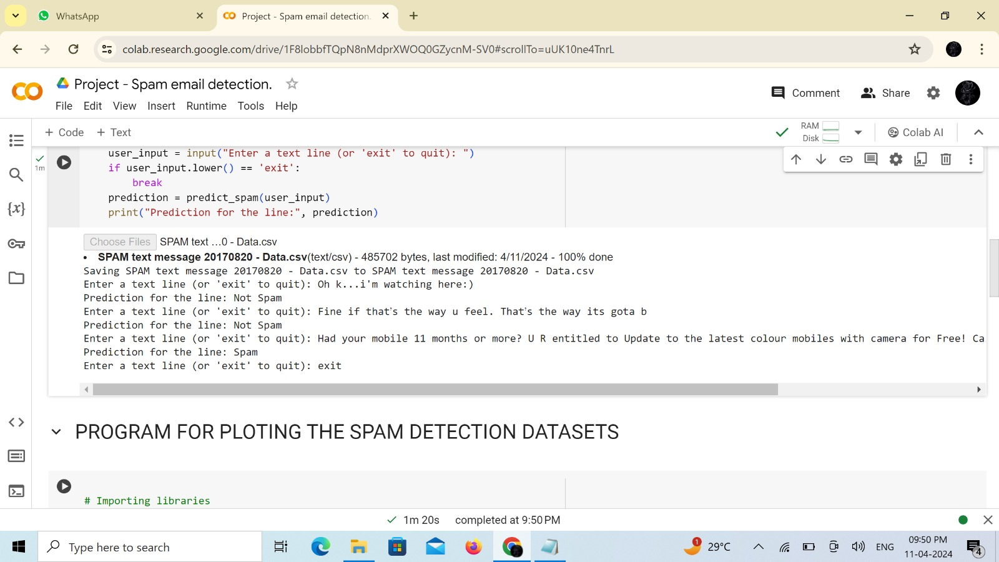

**SPAM EMAIL DETECTION WITH PIE CHART USING DATA SET,**

Importing libraries

from google.colab import files

import pandas as pd

import matplotlib.pyplot as plt

# Load the dataset

uploaded = files.upload()

spamtext = pd.read_csv(next(iter(uploaded)))

# Function to plot pie chart

def plot_pie_chart(spam_count, not_spam_count):

labels = 'Spam', 'Not Spam'

sizes = [spam_count, not_spam_count]

colors = ['gold', 'lightcoral']

explode = (0.1, 0) # explode 1st slice (i.e., 'Spam')

plt.figure(figsize=(7, 7))

plt.pie(sizes, explode=explode, labels=labels, colors=colors, autopct='%1.1f%%', shadow=True, startangle=140)

plt.axis('equal') # Equal aspect ratio ensures that pie is drawn as a circle.

plt.title('Distribution of Spam and Not Spam Messages')

plt.show()

# Preprocessing: Convert labels to binary (0 for ham, 1 for spam)

spamtext['Category'] = spamtext['Category'].apply(lambda x: 1 if x == 'spam' else 0)

# Count the occurrences of spam and not spam

spam_count = (spamtext['Category']

# Plot the pie chart

plot_pie_chart(spam_count, not_spam_count)

**OUTPUT :**

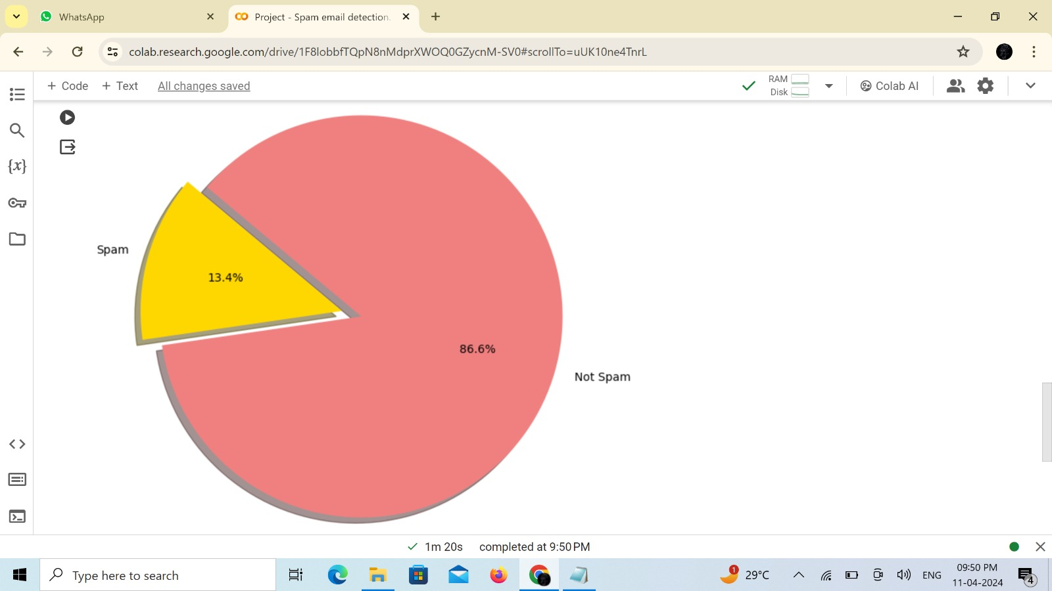

Github Repository link:

https://github.com/Poonkuzhali14/NM--Detecting-spam-Email-.git